Test Case: tc001_SPX_Dev5_Crear_Solicitud_Articulo_Almacen
Step 1 - Enter username and password and click to button Enter : Credentials Entered
Image file-name: QC_Testing-tc001_SPX_Dev5_Crear_Solicitud_Articulo_Almacen-1787870359742

Step 2 - Select to UEN and Access to Request for a New Inventory Item : UEN Correctly selected and Correct access
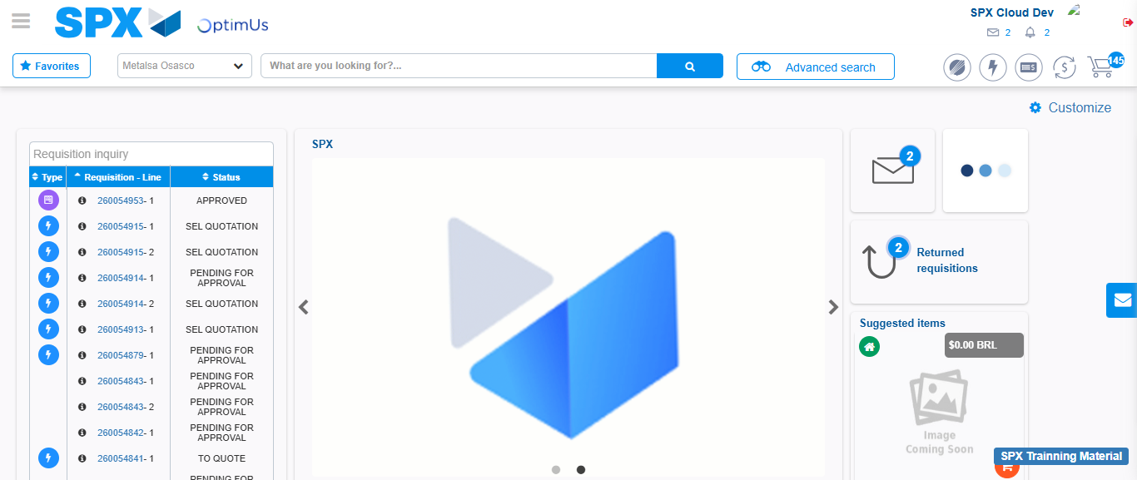Image file-name: QC_Testing-tc001_SPX_Dev5_Crear_Solicitud_Articulo_Almacen-1787870384767

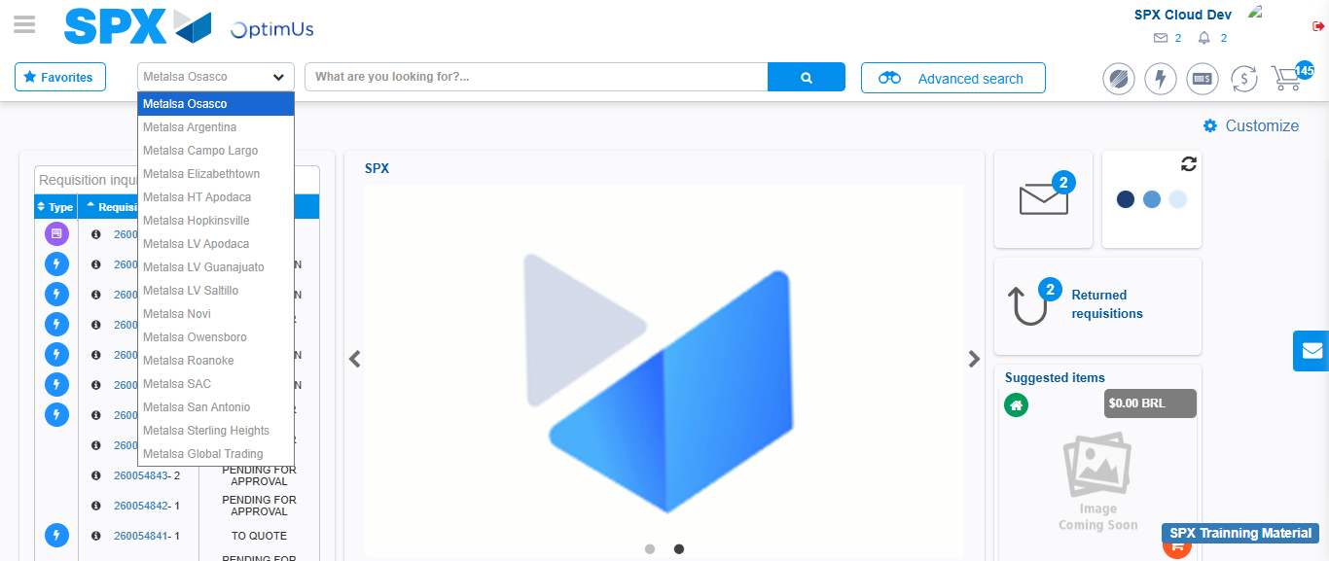Image file-name: QC_Testing-tc001_SPX_Dev5_Crear_Solicitud_Articulo_Almacen-1787870385354

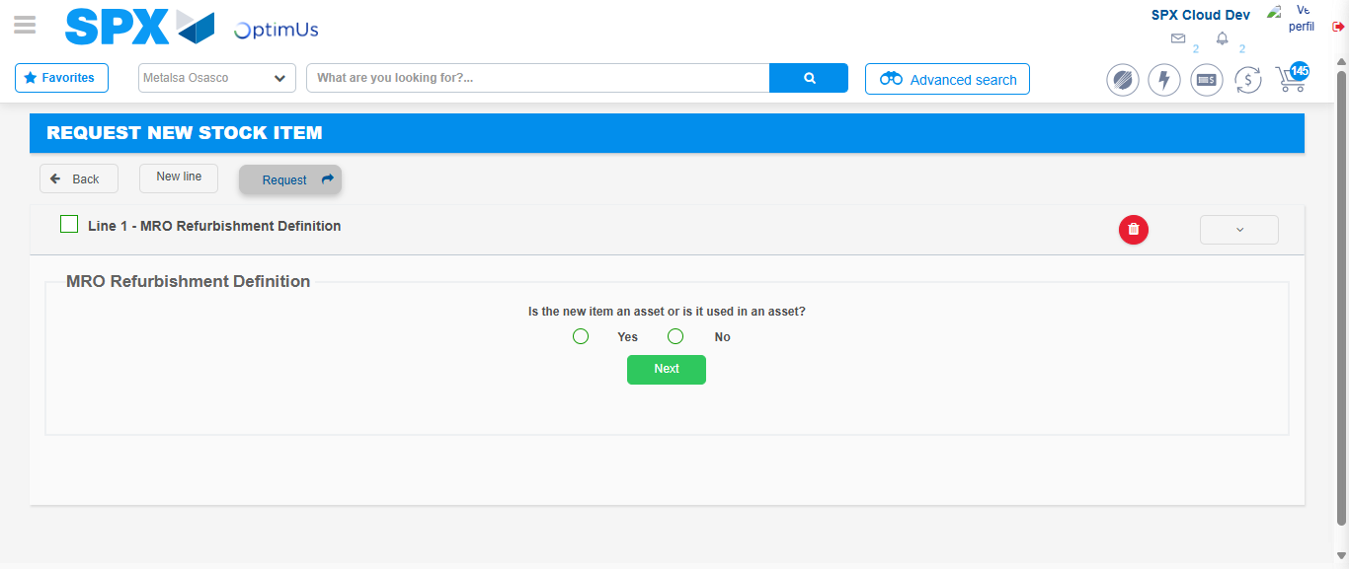Image file-name: QC_Testing-tc001_SPX_Dev5_Crear_Solicitud_Articulo_Almacen-1787870406672

Step 3 - Select options first section : Options seleted correctly
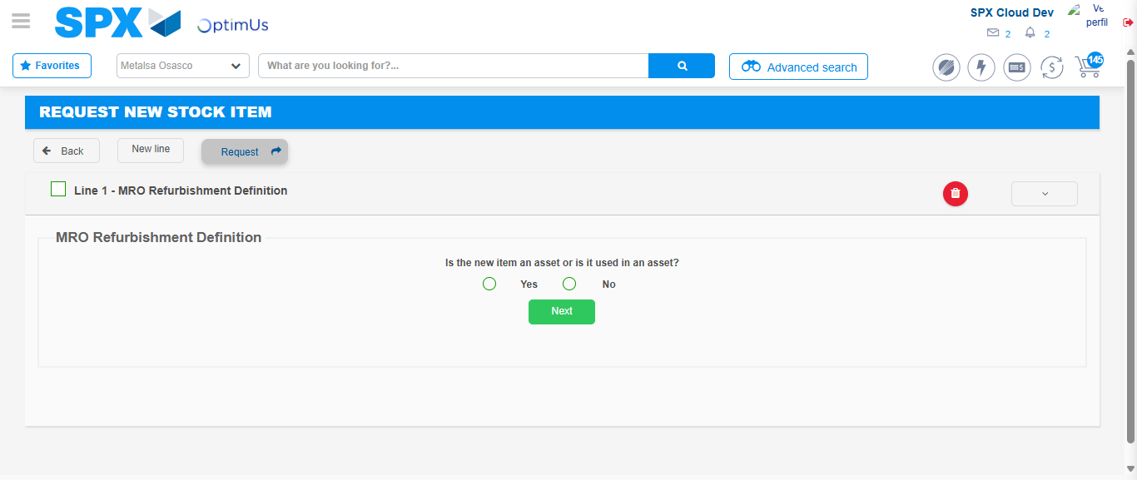Image file-name: QC_Testing-tc001_SPX_Dev5_Crear_Solicitud_Articulo_Almacen-1787870406987

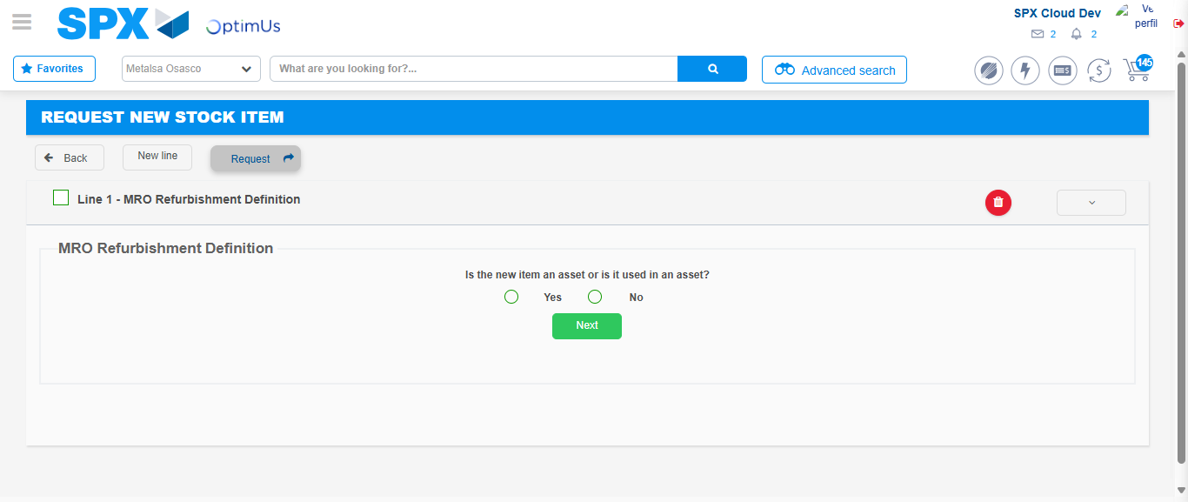Image file-name: QC_Testing-tc001_SPX_Dev5_Crear_Solicitud_Articulo_Almacen-1787870407206

Step 4 - Select options at Screen: Options seleted correctly
Image file-name: QC_Testing-tc001_SPX_Dev5_Crear_Solicitud_Articulo_Almacen-1787870406987

Image file-name: QC_Testing-tc001_SPX_Dev5_Crear_Solicitud_Articulo_Almacen-1787870407206

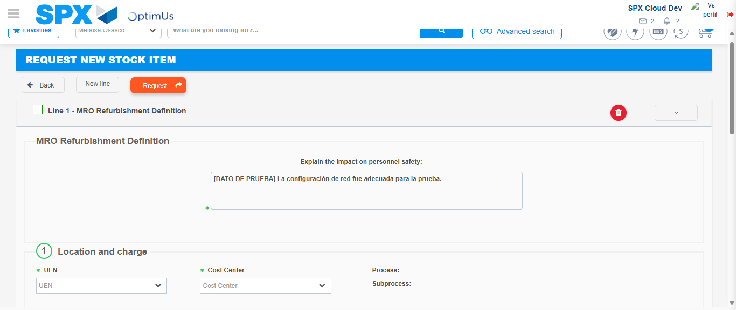Image file-name: QC_Testing-tc001_SPX_Dev5_Crear_Solicitud_Articulo_Almacen-1787870413315

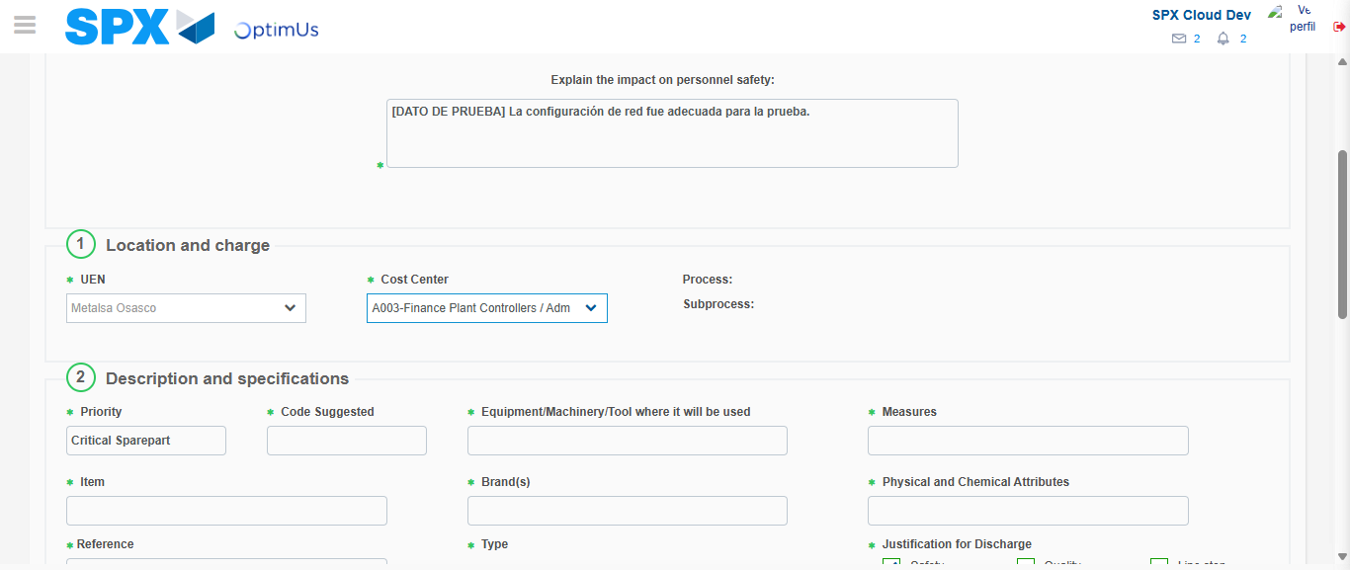Image file-name: QC_Testing-tc001_SPX_Dev5_Crear_Solicitud_Articulo_Almacen-1787870416067

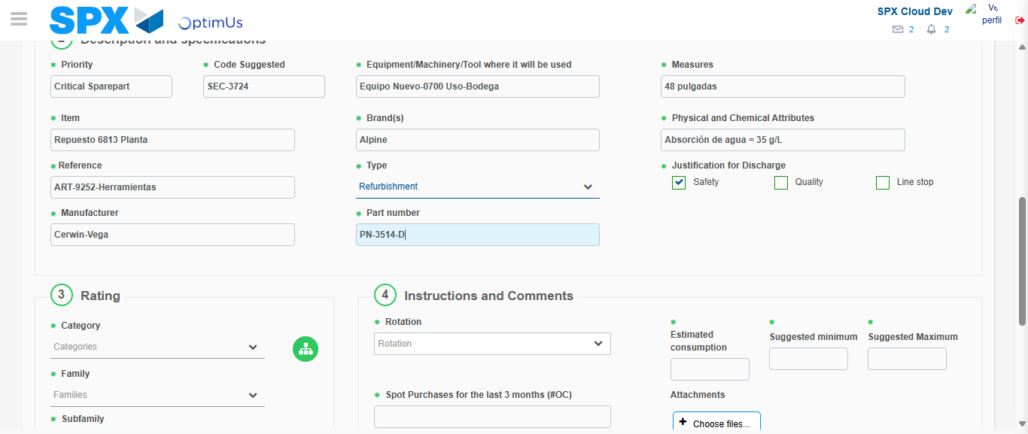Image file-name: QC_Testing-tc001_SPX_Dev5_Crear_Solicitud_Articulo_Almacen-1787870417705

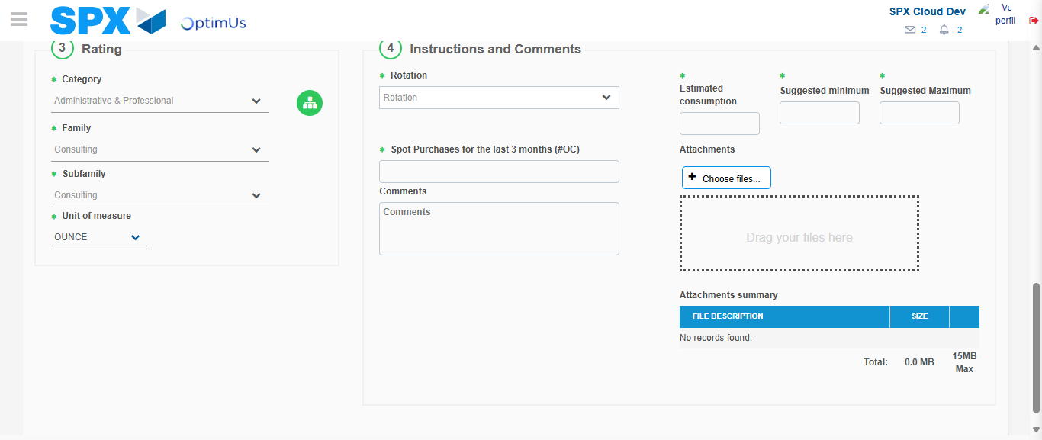Image file-name: QC_Testing-tc001_SPX_Dev5_Crear_Solicitud_Articulo_Almacen-1787870421719

Step 5 - Request New Item : Request Accepted
Image file-name: QC_Testing-tc001_SPX_Dev5_Crear_Solicitud_Articulo_Almacen-1787870384767

Image file-name: QC_Testing-tc001_SPX_Dev5_Crear_Solicitud_Articulo_Almacen-1787870385354

Image file-name: QC_Testing-tc001_SPX_Dev5_Crear_Solicitud_Articulo_Almacen-1787870406672

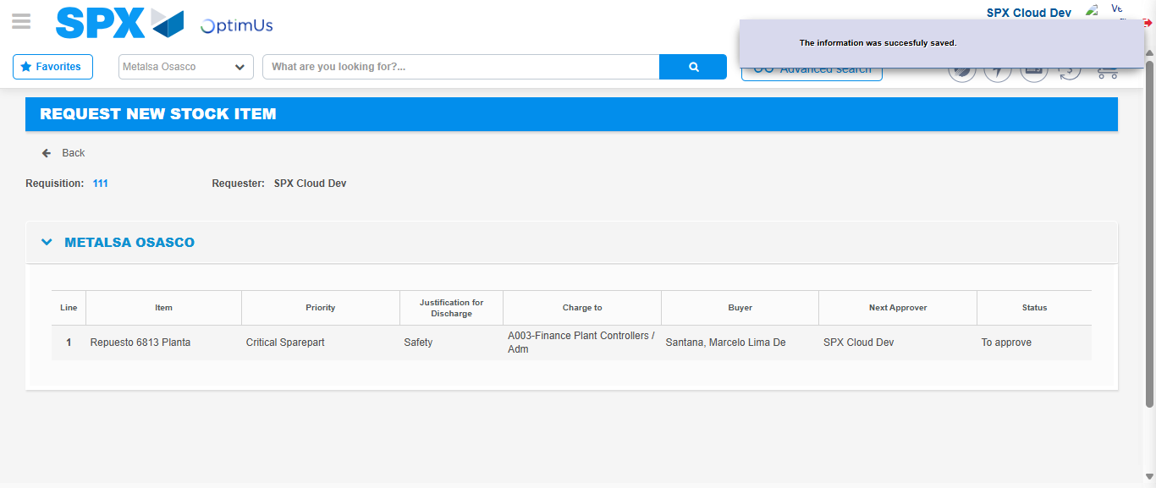Image file-name: QC_Testing-tc001_SPX_Dev5_Crear_Solicitud_Articulo_Almacen-1787870428445

Image file-name: QC_Testing-tc001_SPX_Dev5_Crear_Solicitud_Articulo_Almacen-1787870428609

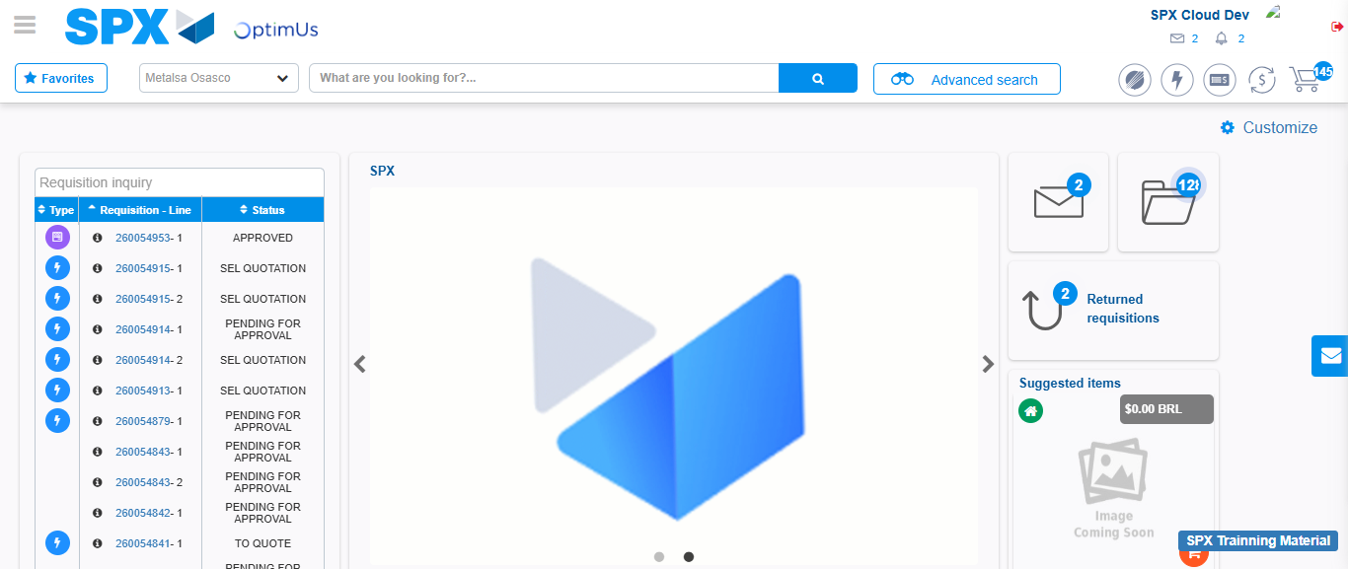Image file-name: QC_Testing-tc001_SPX_Dev5_Crear_Solicitud_Articulo_Almacen-1787870449903

Step 7 - Return to Main Page SPX : Return to Main Page SPX
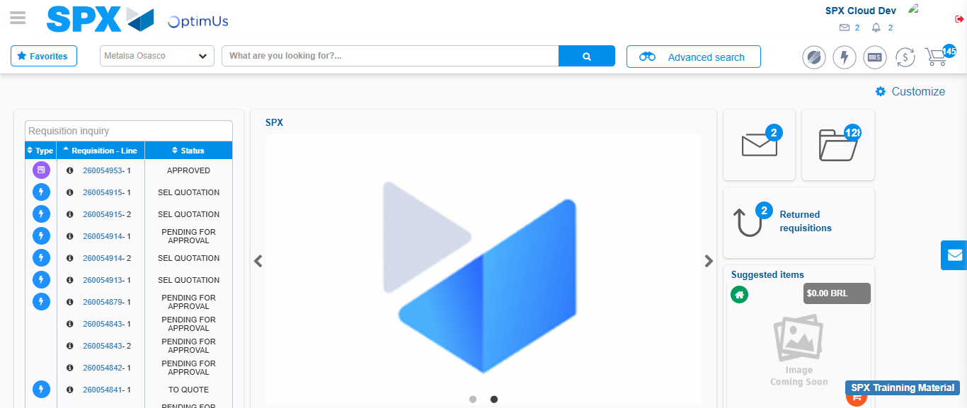Image file-name: QC_Testing-tc001_SPX_Dev5_Crear_Solicitud_Articulo_Almacen-1787870450174

